Coding Games

Andy
https://studio.code.org/c/1794768556

Jandell
https://studio.code.org/projects/spritelab/SNwzWKz40ex9v1Yw49iYYSWJcuG37HimqH4HSCs-TZM
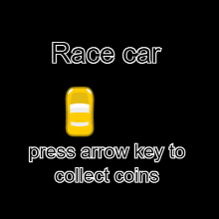 | Check out what I made  I wrote the code myself with Code.org  studio.code.org

Dance Party Coding Projects

Dylan
https://studio.code.org/projects/dance/OyIMC27-kwTUYDuCzk0QPcGT4LZur3y0obCO1RY40kI
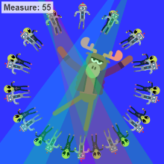 | Check out what I made  I wrote the code myself with Code.org  studio.code.org

Zahir
https://studio.code.org/projects/dance/AazATujlK_0qQqmO4g8FYWciOh1YMvhQHU_dIWQL_s4
Grecia
https://studio.code.org/projects/dance/SqYcnlc1X-7BIPQyMHY2SW6YLoZXK6wiIGgyARG8_1w
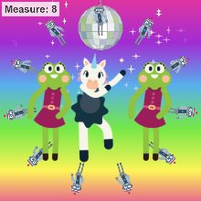 | Check out what I made  I wrote the code myself with Code.org  studio.code.org

Karen
https://studio.code.org/projects/dance/bHKWTrZd46eSvuWY7va4wksNTuLUj6Ws0jXf571ZnwA
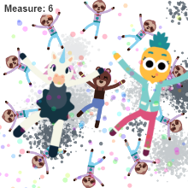 | Check out what I made  I wrote the code myself with Code.org  studio.code.org

Danyel
https://studio.code.org/projects/dance/wz84bhDxuP37GFS6_s8BEjOYaCYOPUsdN55BiF-AJKE
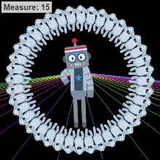 | Check out what I made  I wrote the code myself with Code.org  studio.code.org

Abeer
https://studio.code.org/projects/dance/3MtIHNpOU-_cjkT5lZHPwI9HjJr0z6s2J7getGCSrXU
Jasena
https://studio.code.org/projects/dance/r6NcEBAebekwF1io_GUCRyXTOi-EP8CbNeALCk_wLKA
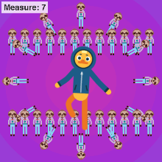 | Check out what I made  I wrote the code myself with Code.org  studio.code.org

Katie
https://studio.code.org/projects/dance/BT_fhvyD2y-PeAKFkIjqp2tXEj0VoK8qVXLVvlTBpMo

Minecraft Coding
Danyel
https://studio.code.org/c/1796883371
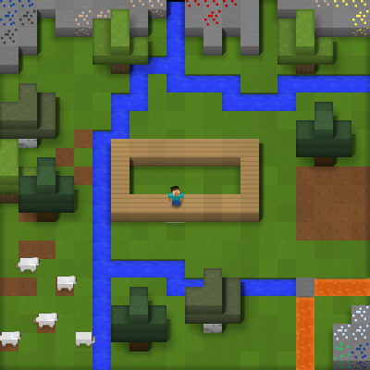 | Check out what I made  I wrote the code myself with Code.org  studio.code.org

Vesper

https://studio.code.org/c/1798500808

Taleen
https://studio.code.org/c/1798159841
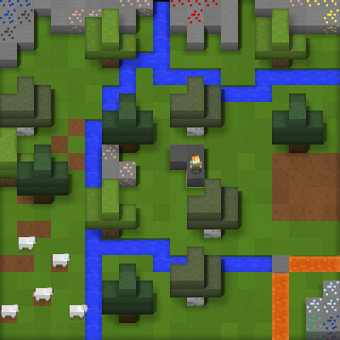 | Code.org  I wrote the code myself with Code.org  studio.code.org

Danyel
https://studio.code.org/c/1798573961

David
https://studio.code.org/c/1798623233
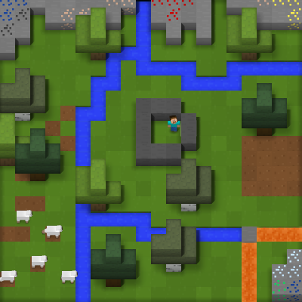 | Check out what I made  I wrote the code myself with Code.org  studio.code.org

Destiny
https://studio.code.org/c/1798686044
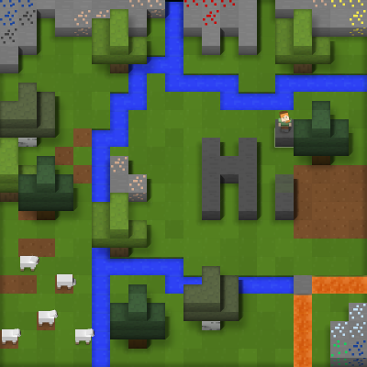 | Check out what I made  I wrote the code myself with Code.org  studio.code.org

Alex
https://studio.code.org/c/1798529645

Robert
https://studio.code.org/c/1798717911

SARAH
https://studio.code.org/c/1798852627

Andy
https://studio.code.org/c/1517634977
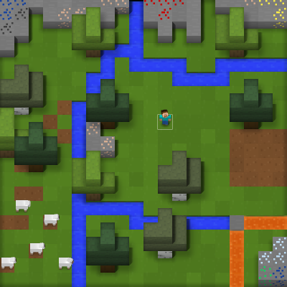 | Check out what I made  I wrote the code myself with Code.org  studio.code.org

